**COMP.4040 HW4 Solution**

1. **Solution**(credit from Salvati Douglas):

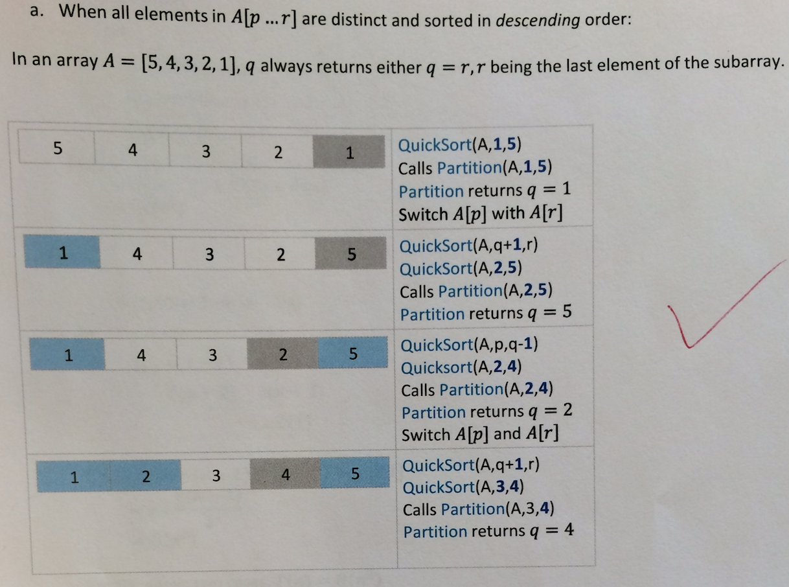

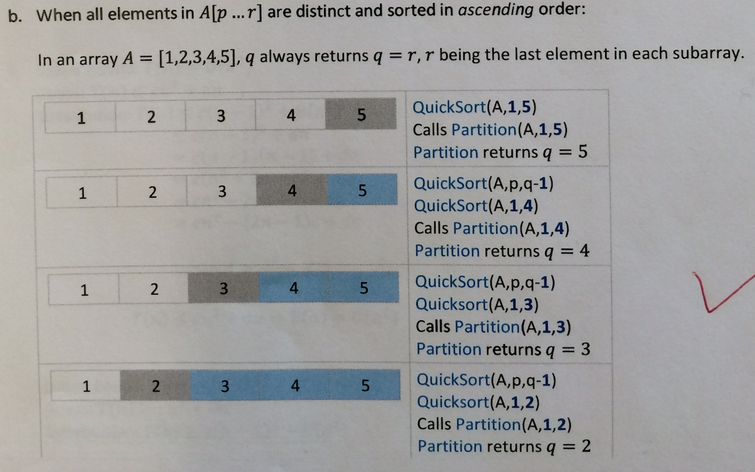

1. **Solution**(credit from Gao Gao):

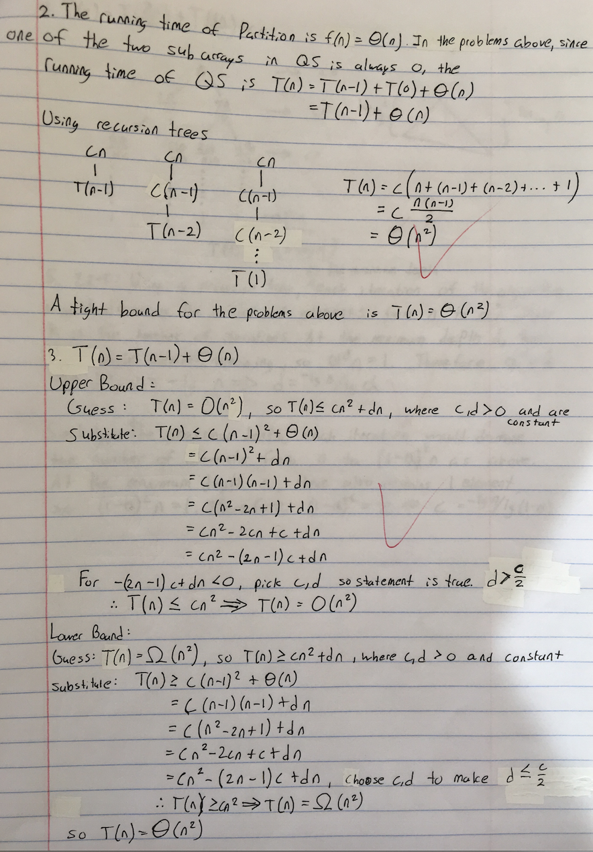

1. **Solution**(credit from Evan O’Leary):

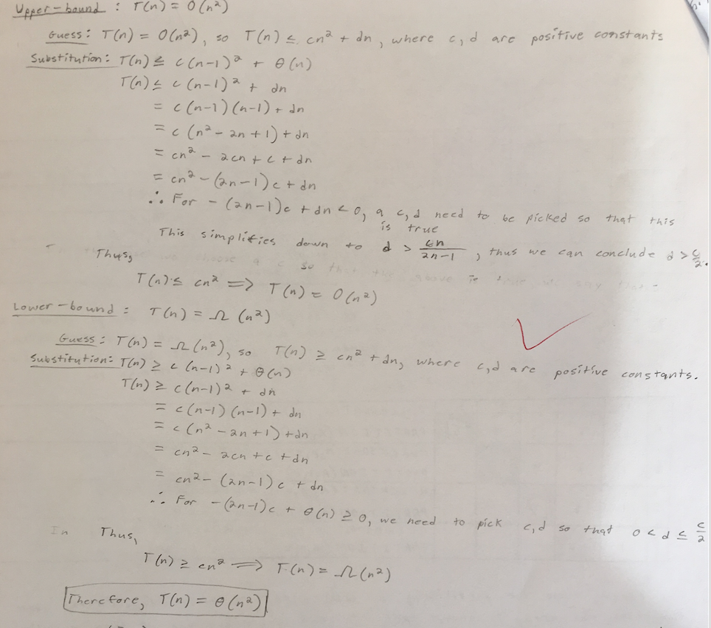

1. **Solution**(credit from Wei Ma):

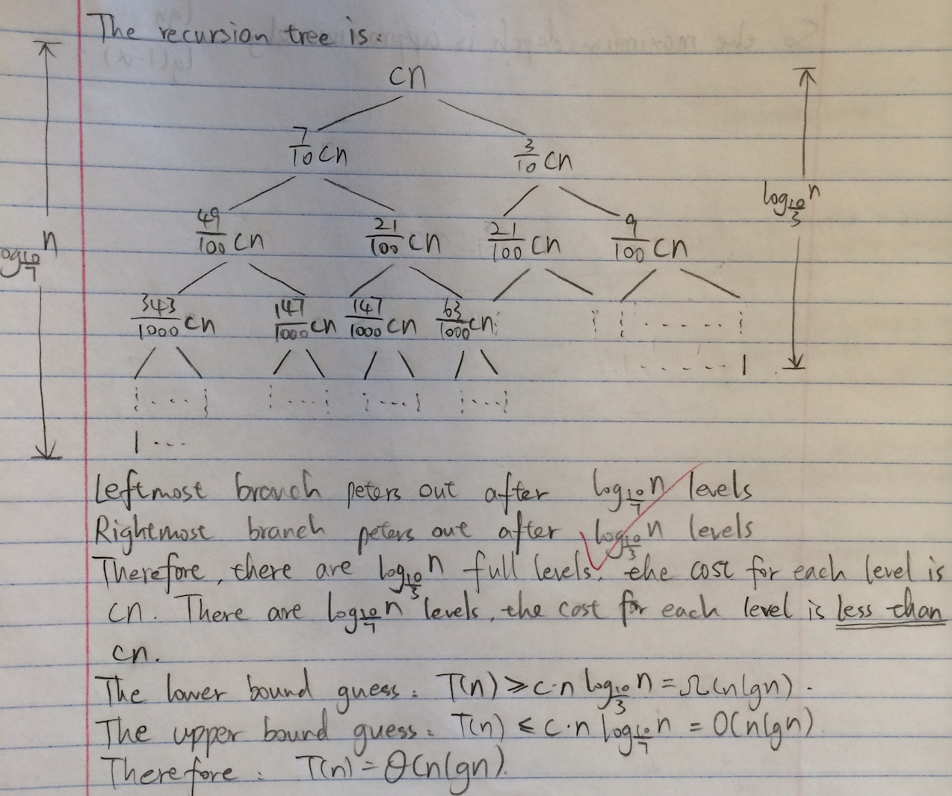

1. **Solution**(credit from Gao Gao):

